Setting up one Agent

1. Login to your linux machine.
2. Go to Dynatrace platform ,and click on OneAgent tab

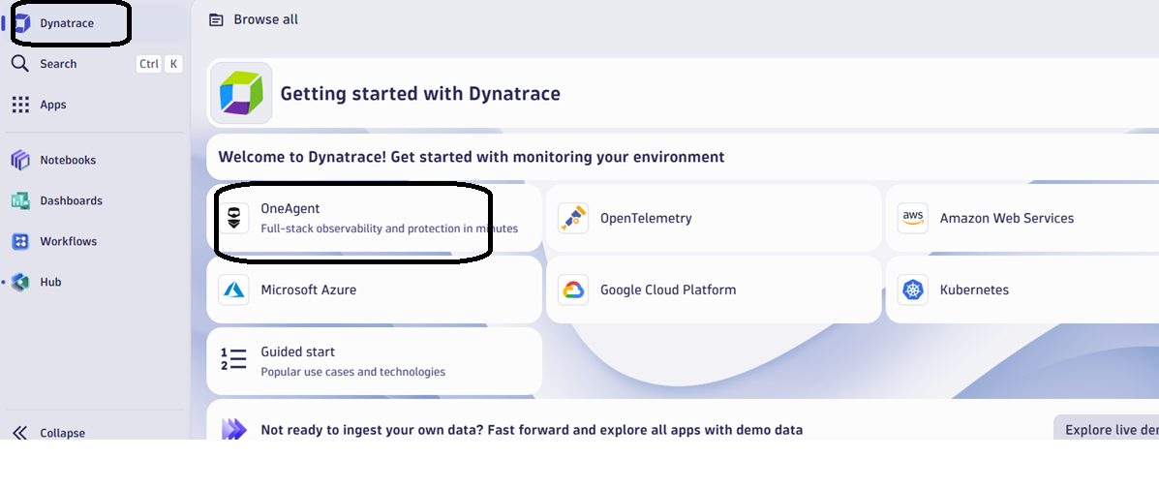

1. Click on Setup

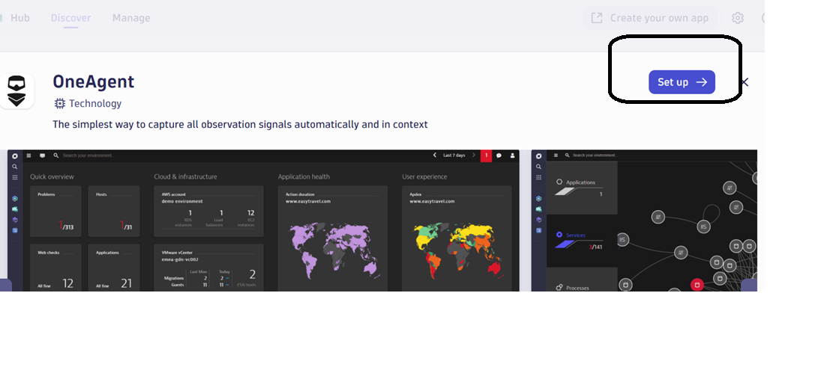

1. Click on generate token

On same page you will find all the three links, perform it

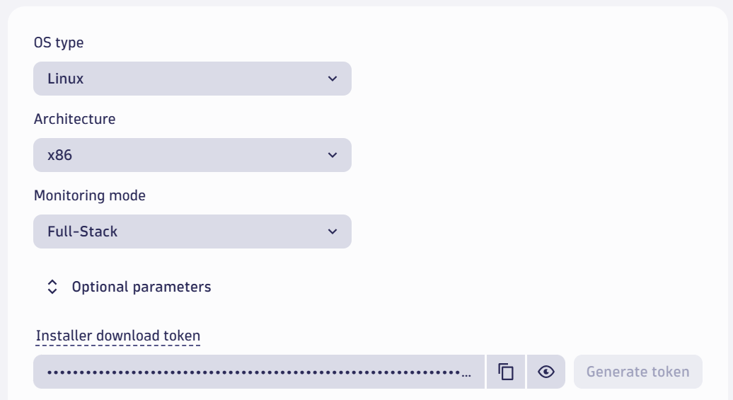

Perform steps

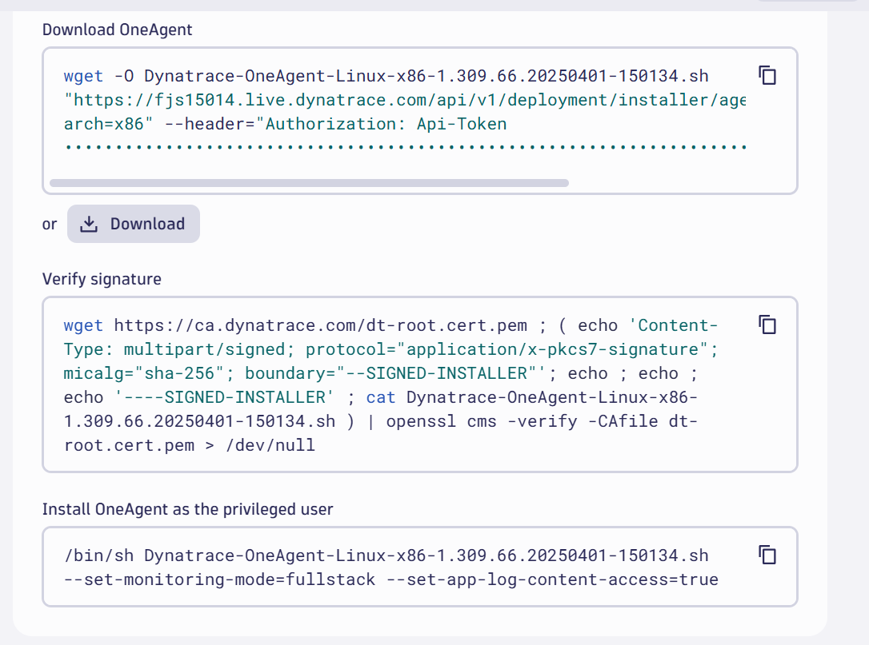

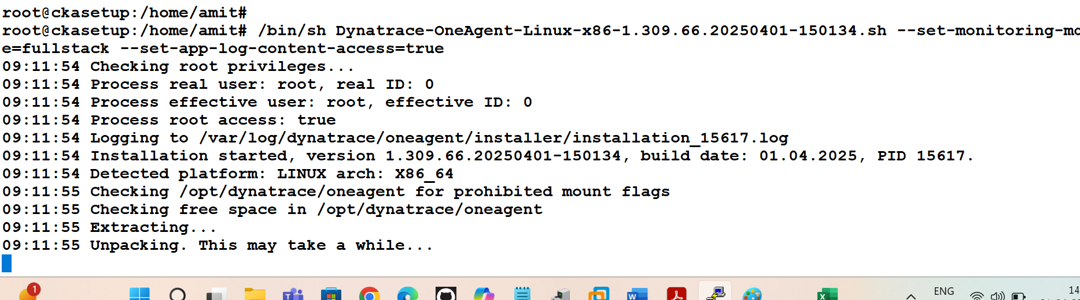

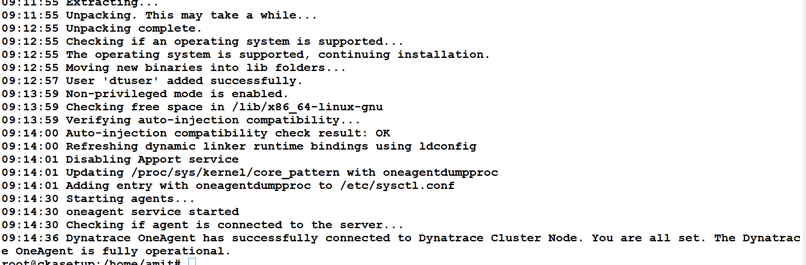

Go to App folder and search for host

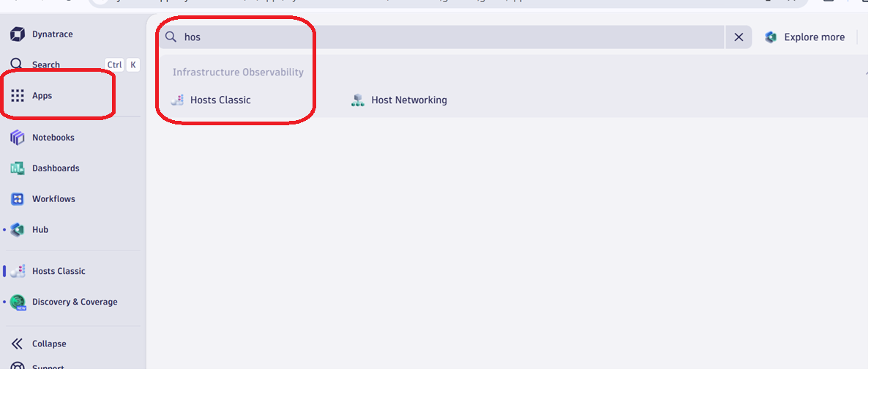

Find the host

